You are given an array points representing integer coordinates of some points on a 2D-plane, where points[i] = [xi, yi].

The cost of connecting two points [xi, yi] and [xj, yj] is the **manhattan distance** between them: |xi - xj| + |yi - yj|, where |val| denotes the absolute value of val.

Return *the minimum cost to make all points connected.* All points are connected if there is **exactly one** simple path between any two points.

**Example 1:**

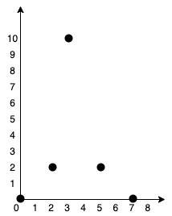

Input: points = [[0,0],[2,2],[3,10],[5,2],[7,0]]  
Output: 20  
Explanation:   
  
We can connect the points as shown above to get the minimum cost of 20.  
Notice that there is a unique path between every pair of points.

**Example 2:**

Input: points = [[3,12],[-2,5],[-4,1]]  
Output: 18

**Constraints:**

* 1 <= points.length <= 1000
* -106 <= xi, yi <= 106
* All pairs (xi, yi) are distinct.